Task - 5

Part - 1

1.flag{first_fl@g_h3r3}

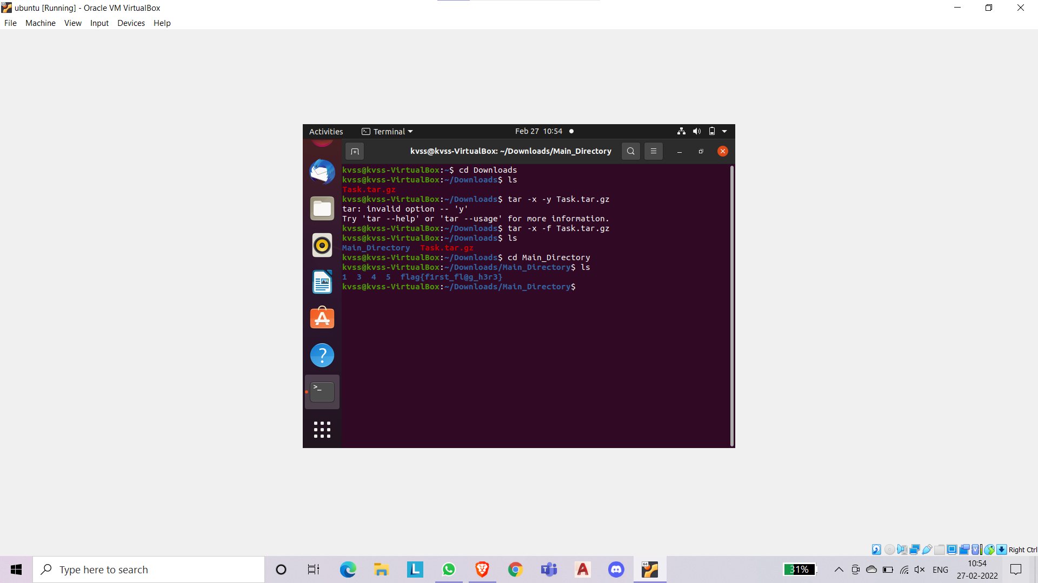

2.flag{e@5y_p@ssw0rd}

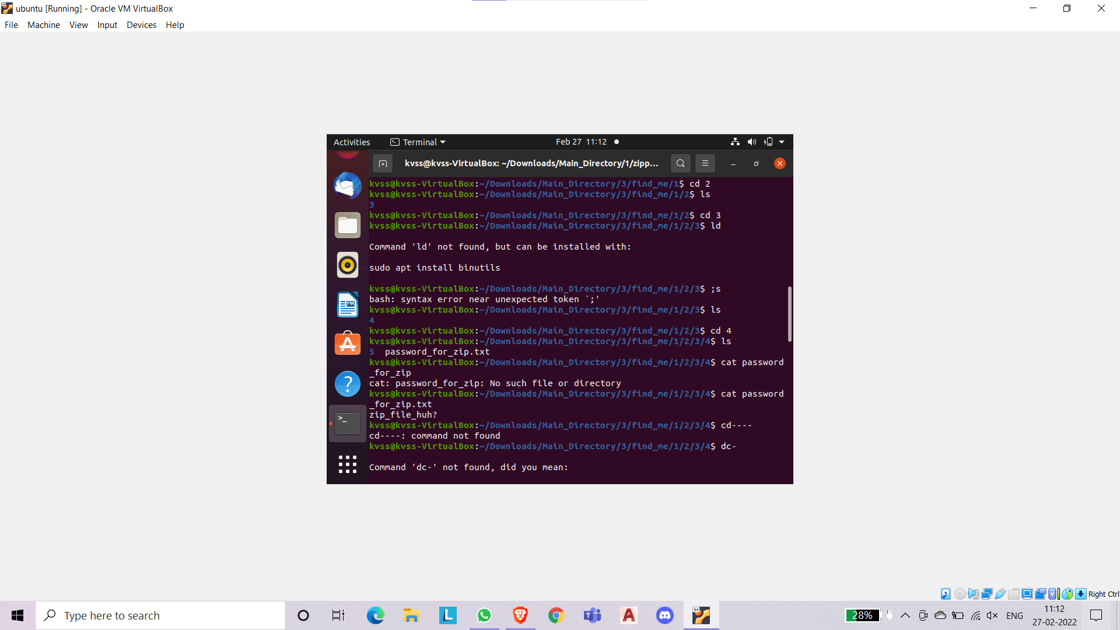

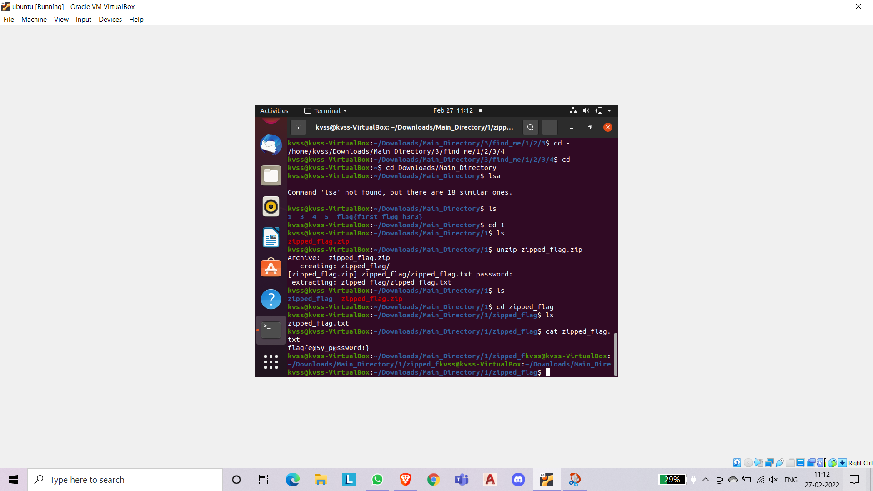

3.flag{gr3p_finds_fl@gs!}

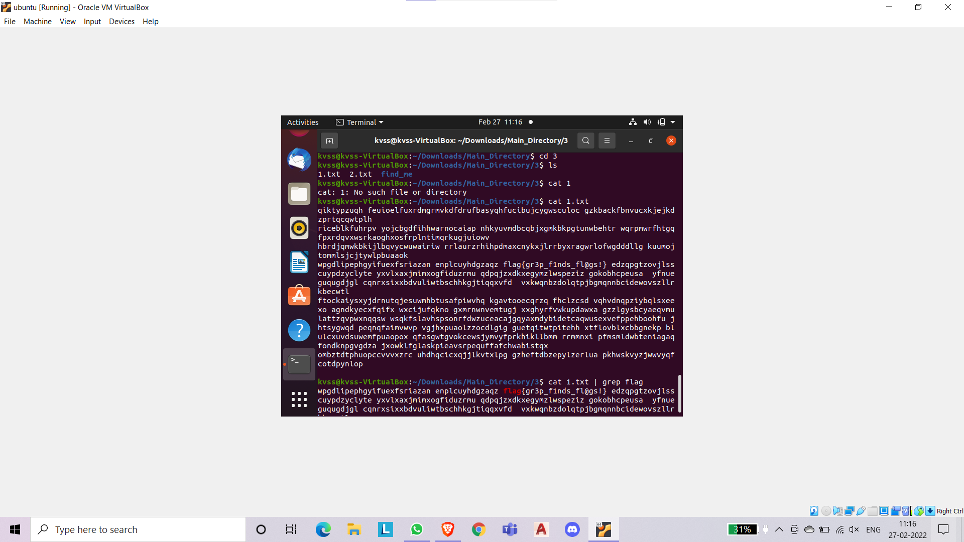

4.flag{m3ow_m3ow_cat!}

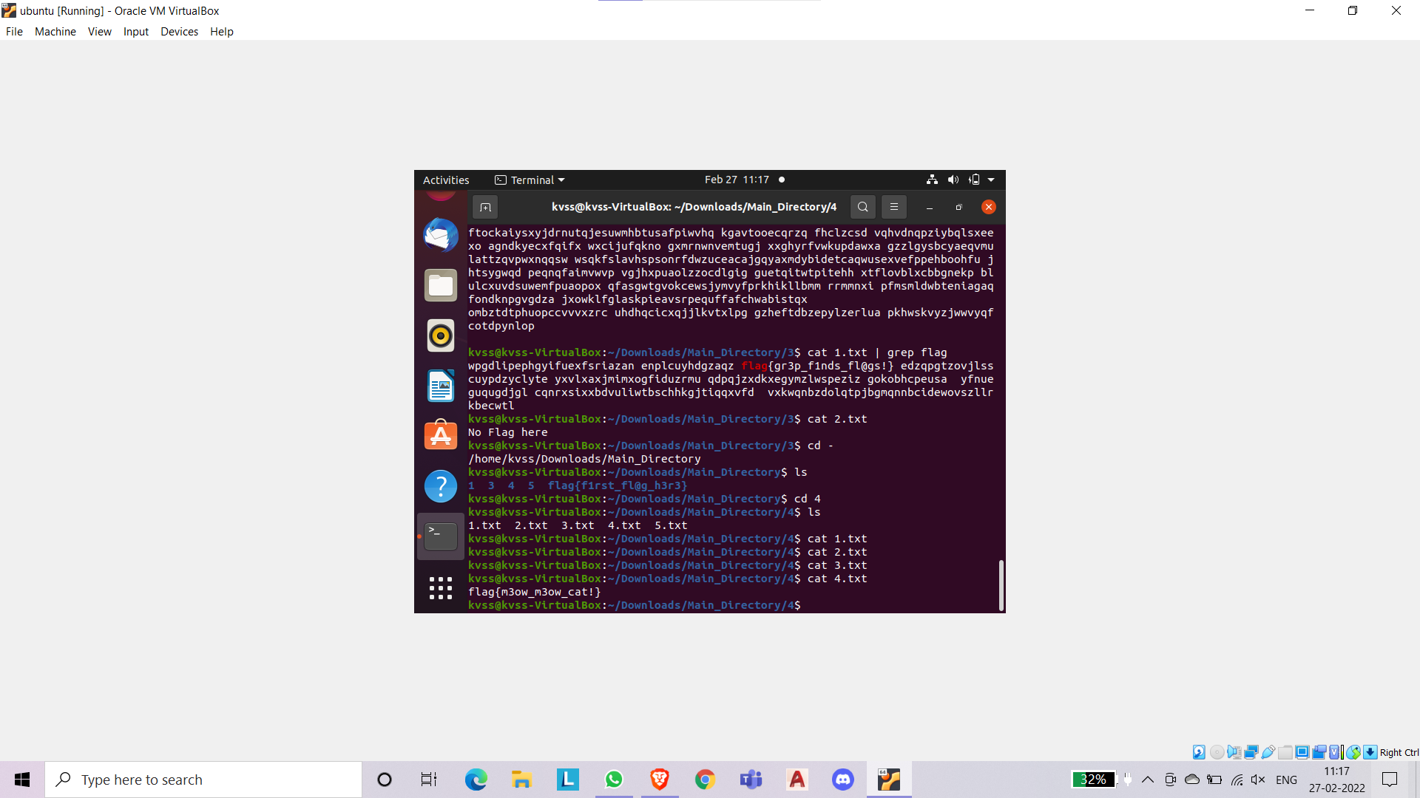

5.flag{t@c_15_fun!}

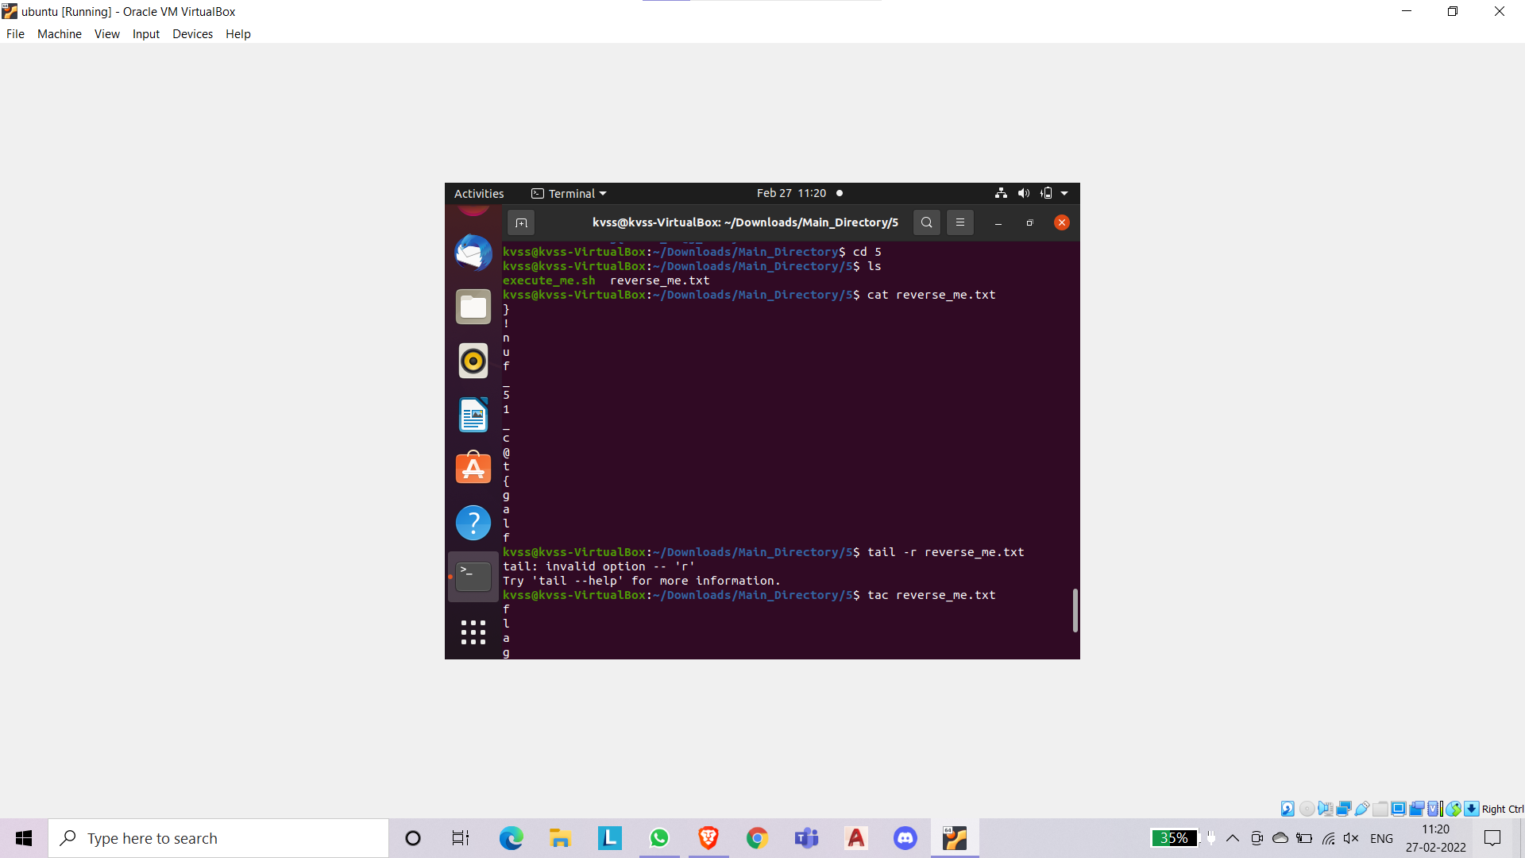

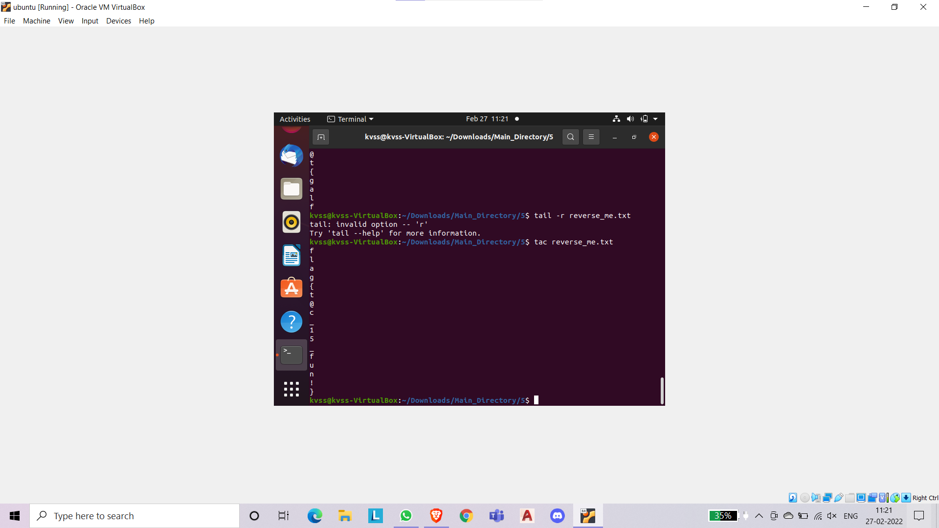

6.flag{3x3cuti0n_d0n3!}

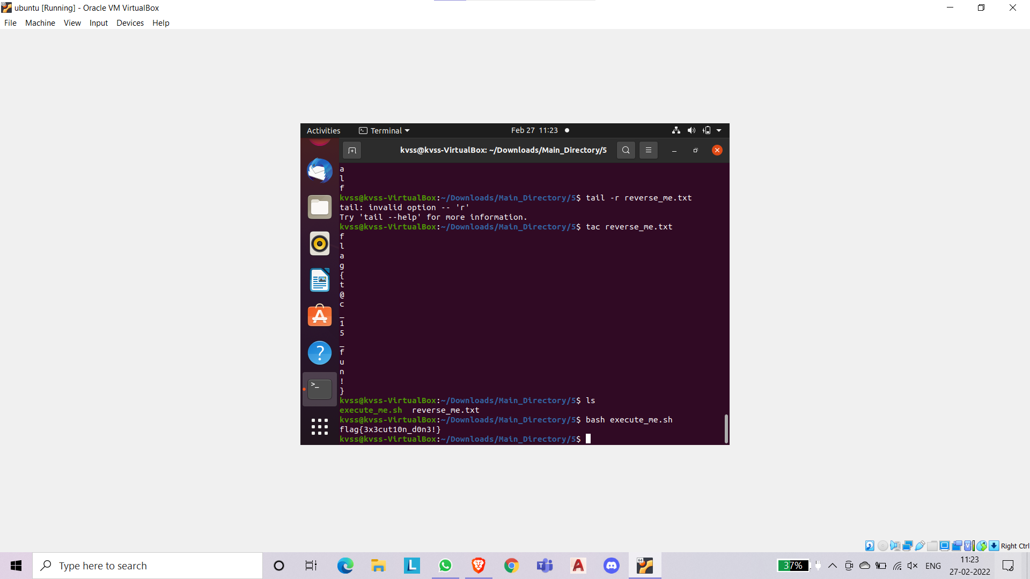

7.flag{Y0u_f0und_m3!}

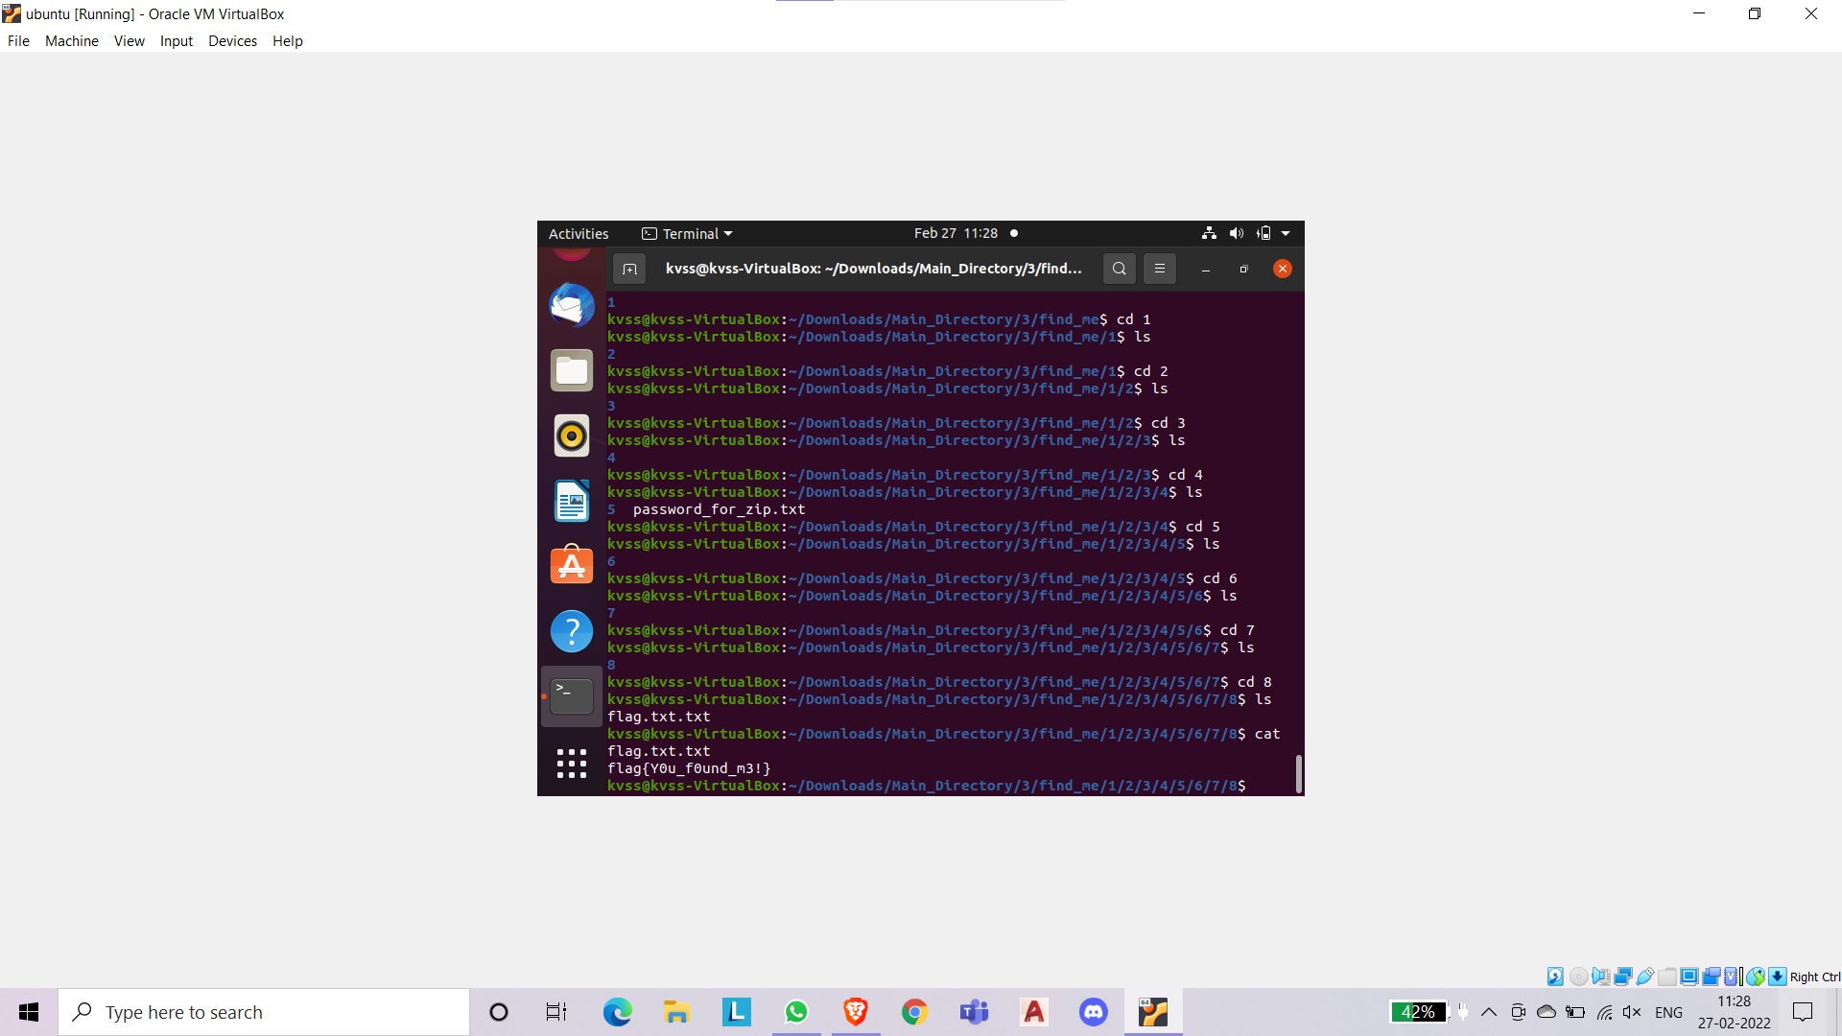

8.flag{Y0u_f0und_th3_hidd3n_dir!}

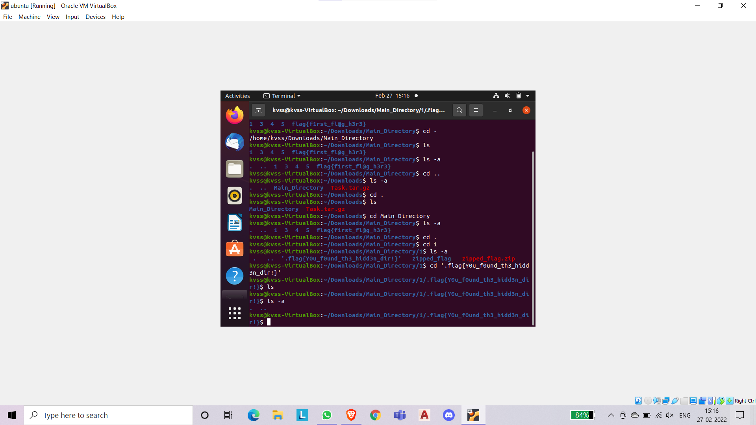

9.flag{h1dden_fil3!}

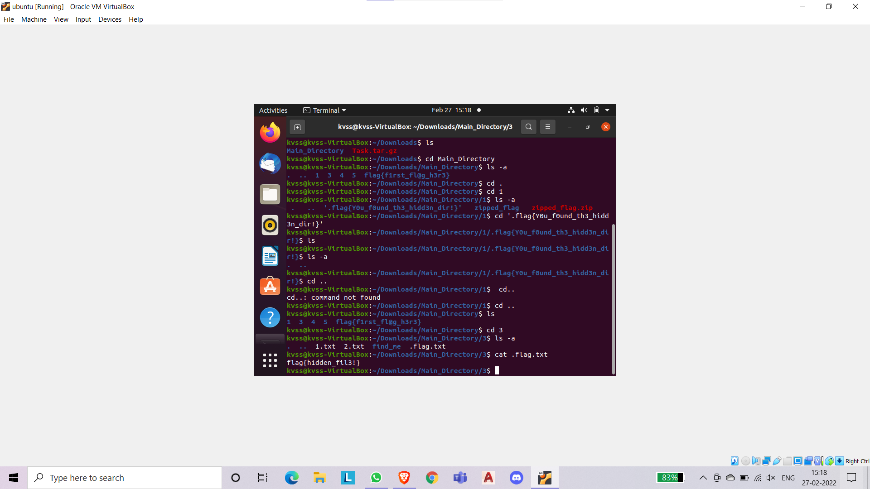

10.flag{t3xt_15_n0t_hidd3n!}

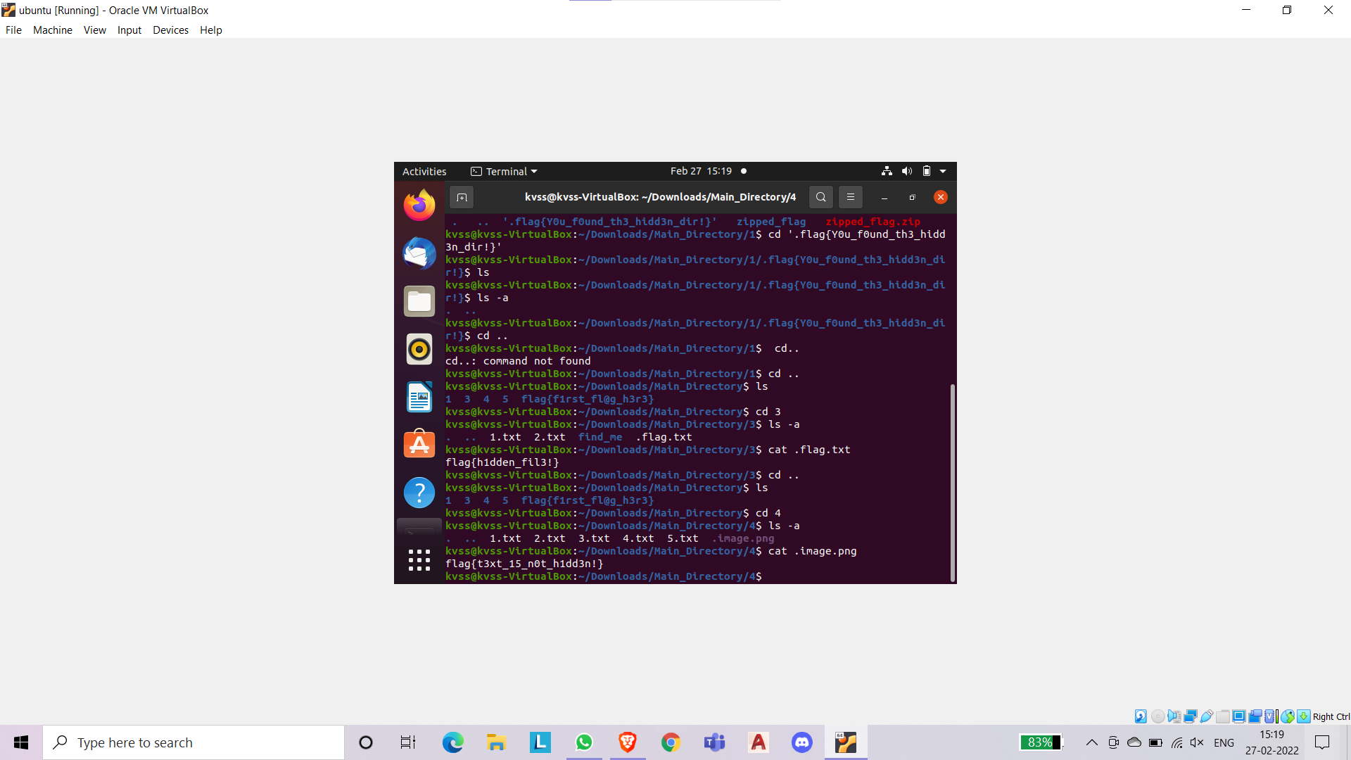

11.flag{d1ff_15_u53ful!}

